Git Hub : https://github.com/mankumarbhalodiya/Digital-Signal-and-Image-Processing
AIM: Design Butterworth and Chebyshev filter using bilinear transformation method.
Theory: The bilinear transformation method is commonly used to design analog filters and then convert them into digital filters. This method maps the analog frequency response to the digital frequency response using a bilinear transformation. The Butterworth and Chebyshev filters are two commonly used filter types. The Butterworth filter has a maximally flat frequency response in the passband, while the Chebyshev filter allows for a sharper transition between the passband and the stopband at the expense of ripples in either the passband or stopband.

Code :
import numpy as np
import matplotlib.pyplot as plt
from scipy.signal import butter, bilinear, freqz, cheby1
def design_butterworth_filter(n, fc, fs):
b, a = butter(n, fc, analog=True, btype='low')
b, a = bilinear(b, a, fs)
return b, a
def design_chebyshev_filter(n, fc, fs, rp):
b, a = cheby1(n, rp, fc, analog=True, btype='low')
b, a = bilinear(b, a, fs)
return b, a
def plot_filter_response(b, a, fs):
f, h = freqz(b, a, fs=fs)
plt.figure(figsize=(10, 6))
plt.plot(f, np.abs(h))
plt.title('Magnitude Response - Man Bhalodiya')
plt.xlabel('Frequency (Hz)')
plt.ylabel('Magnitude')
plt.grid()
plt.show()
_, h = freqz(b, a, worN=4096)
plt.figure(figsize=(10, 6))
plt.plot(h)
plt.title('Impulse Response - Man Bhalodiya')
plt.xlabel('Samples')
plt.ylabel('Amplitude')
plt.grid()
plt.show()
n = 4
fc = 1000
fs = 8000
rp = 0.5
b, a = design_butterworth_filter(n, fc, fs)
plot_filter_response(b, a, fs)
b, a = design_chebyshev_filter(n, fc, fs, rp)
plot_filter_response(b, a, fs)
np.savetxt('filter_coefficients.txt', np.vstack((b, a)), delimiter=',')

Output :
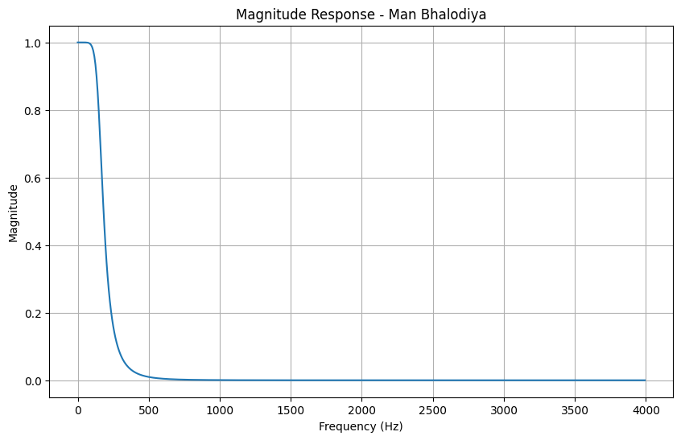

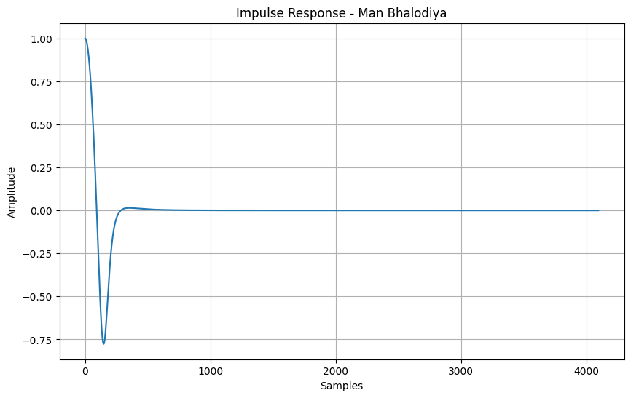
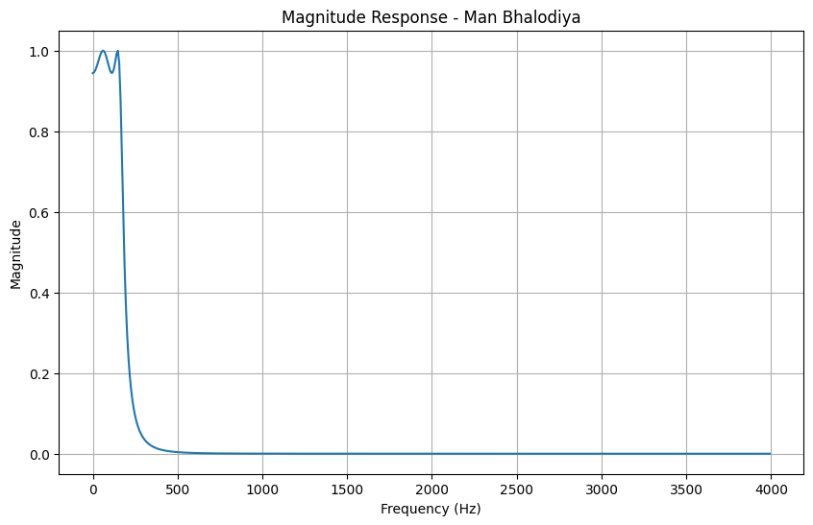
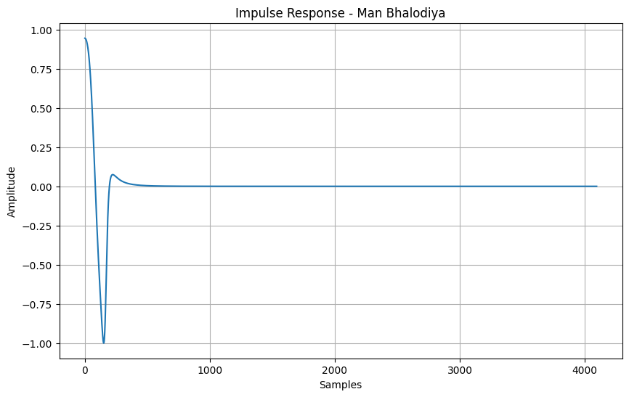
Additional Task :
1.Generate a discrete sine wave of 1KHz, 2KHz, 3KHz, 4 KHz. Plot all these.

Code :
import numpy as np
import matplotlib.pyplot as plt
fs = 10000
t = np.arange(0, 0.01, 1/fs)
x1 = np.sin(2*np.pi*1000*t)
x2 = np.sin(2*np.pi*2000*t)
x3 = np.sin(2*np.pi*3000*t)
x4 = np.sin(2*np.pi*4000*t)
plt.figure(figsize=(10,8))
plt.subplot(4,1,1)
plt.stem(t,x1)
plt.title("1 kHz Sine Wave-Man Bhalodiya")
plt.grid()
plt.subplot(4,1,2)
plt.stem(t,x2)
plt.title("2 kHz Sine Wave-Man Bhalodiya")
plt.grid()
plt.subplot(4,1,3)
plt.stem(t,x3)
plt.title("3 kHz Sine Wave-Man Bhalodiya")
plt.grid()
plt.subplot(4,1,4)
plt.stem(t,x4)
plt.title("4 kHz Sine Wave-Man Bhalodiya")
plt.grid()
plt.tight_layout()
plt.show()

Output :
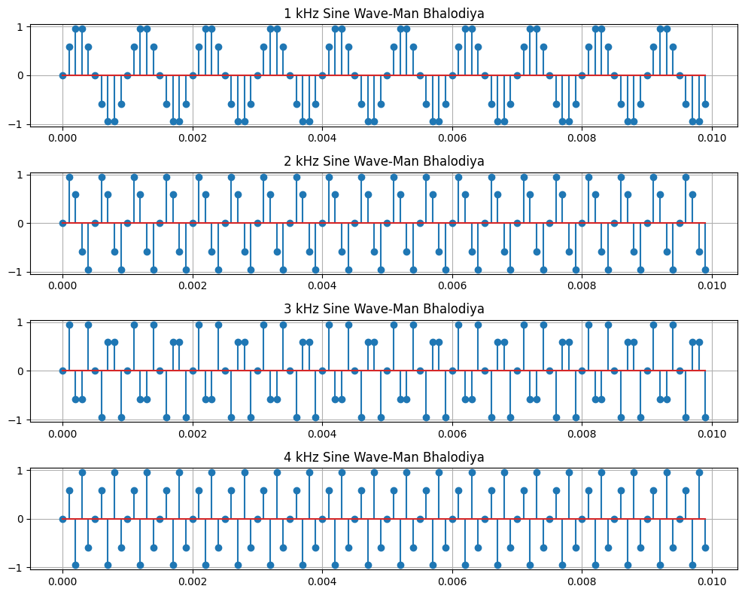
2. Add all these four signal and plot it in time as well as frequency domain
Code :
import numpy as np
import matplotlib.pyplot as plt
fs = 10000
t = np.arange(0, 0.01, 1/fs)
x1 = np.sin(2*np.pi*1000*t)
x2 = np.sin(2*np.pi*2000*t)
x3 = np.sin(2*np.pi*3000*t)
x4 = np.sin(2*np.pi*4000*t)
x = x1 + x2 + x3 + x4
plt.figure(figsize=(10,4))
plt.stem(t,x)
plt.title("Added Signal - Time Domain - Man Bhalodiya")
plt.xlabel("Time (s)")
plt.ylabel("Amplitude")
plt.grid()
plt.show()
X = np.fft.fft(x)
freq = np.fft.fftfreq(len(x),1/fs)
plt.figure(figsize=(10,4))
plt.stem(freq[:len(freq)//2],np.abs(X[:len(X)//2]))
plt.title("Added Signal - Frequency Domain - Man Bhalodiya")
plt.xlabel("Frequency (Hz)")
plt.ylabel("Magnitude")
plt.grid()
plt.show()

Output :
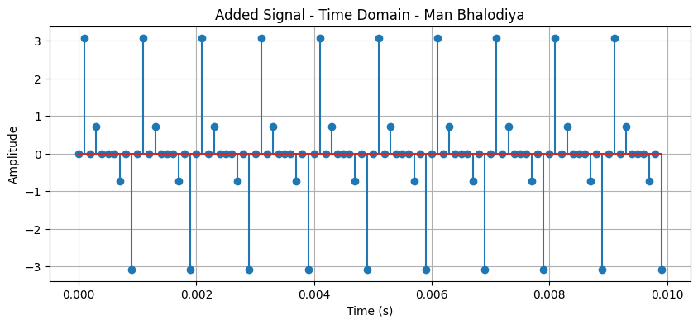
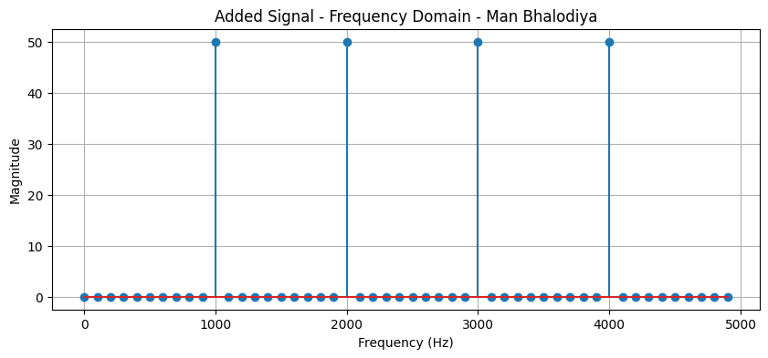

3.pass through buttorworth digital filter having cutoff frequency 2 khz and plot the output plot in time as well as frequency domain
Code :
import numpy as np
import matplotlib.pyplot as plt
from scipy.signal import butter, filtfilt
fs = 10000
t = np.arange(0, 0.01, 1/fs)
x1 = np.sin(2*np.pi*1000*t)
x2 = np.sin(2*np.pi*2000*t)
x3 = np.sin(2*np.pi*3000*t)
x4 = np.sin(2*np.pi*4000*t)
x = x1 + x2 + x3 + x4
b, a = butter(4, 2000/(fs/2), btype='low')
y = filtfilt(b, a, x)
plt.figure(figsize=(10,4))
plt.plot(t, y)
plt.title("Butterworth Output - Time Domain - Man Bhalodiya")
plt.xlabel("Time (s)")
plt.ylabel("Amplitude")
plt.grid()
plt.show()
Y = np.fft.fft(y)
freq = np.fft.fftfreq(len(y), 1/fs)
plt.figure(figsize=(10,4))
plt.plot(freq[:len(freq)//2], np.abs(Y[:len(Y)//2]))
plt.title("Butterworth Output - Frequency Domain - Man Bhalodiya")
plt.xlabel("Frequency (Hz)")
plt.ylabel("Magnitude")
plt.grid()
plt.show()
Output :

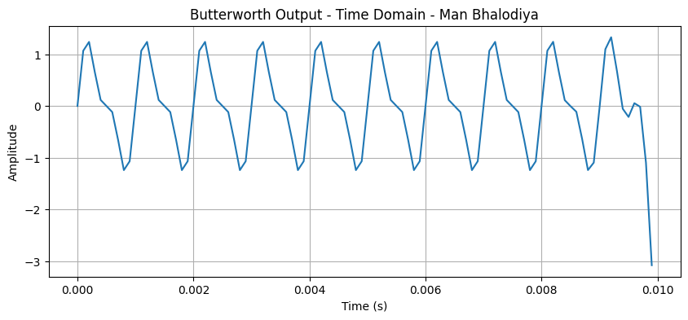
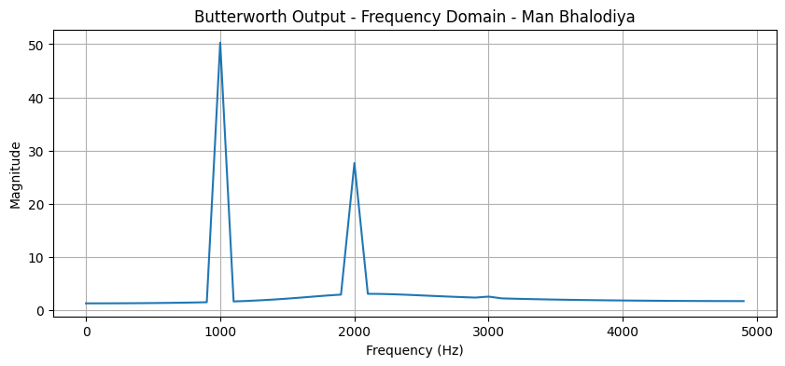
4. Pass through chebyschev digital filter having cutoff frequency 3KHz and plot the output plot in time as well as frequency domain
Code :
import numpy as np
import matplotlib.pyplot as plt
from scipy.signal import cheby1, filtfilt
fs = 10000
t = np.arange(0, 0.01, 1/fs)
x1 = np.sin(2*np.pi*1000*t)
x2 = np.sin(2*np.pi*2000*t)
x3 = np.sin(2*np.pi*3000*t)
x4 = np.sin(2*np.pi*4000*t)
x = x1 + x2 + x3 + x4
b, a = cheby1(4, 0.5, 3000/(fs/2), btype='low')
y = filtfilt(b, a, x)
plt.figure(figsize=(10, 4))
plt.plot(t, y)
plt.title("Chebyshev Output - Time Domain - Man Bhalodiya")
plt.xlabel("Time (s)")
plt.ylabel("Amplitude")
plt.grid()
plt.show()
Y = np.fft.fft(y)
freq = np.fft.fftfreq(len(y), 1/fs)
plt.figure(figsize=(10, 4))
plt.plot(freq[:len(freq)//2], np.abs(Y[:len(Y)//2]))
plt.title("Chebyshev Output - Frequency Domain - Man Bhalodiya") plt.xlabel("Frequency (Hz)")
plt.ylabel("Magnitude") plt.grid() plt.show()
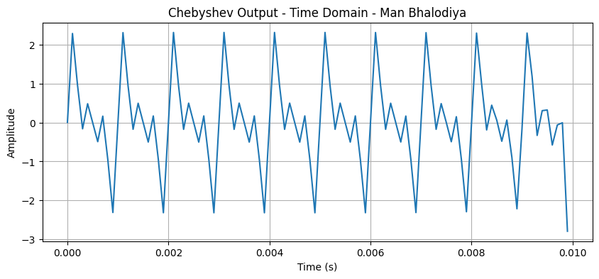
Output :
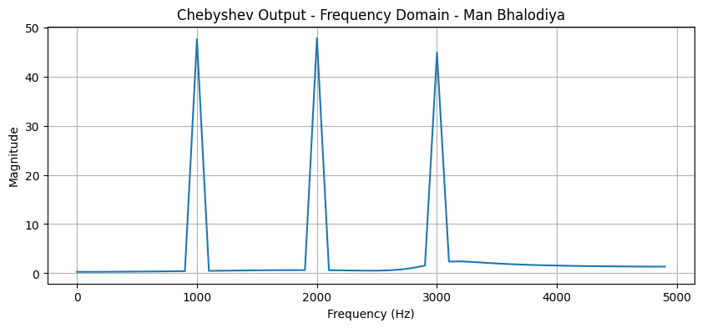

Conclusion : In this experiment, a Chebyshev low-pass filter was used to filter the combined signal of four sine waves with frequencies of 1 kHz, 2 kHz, 3 kHz, and 4 kHz. The output was observed in both the time and frequency domains. The filter reduced higher-frequency components while allowing lower-frequency components to pass. Thus, the experiment helped us understand how a Chebyshev filter works in signal processing.

